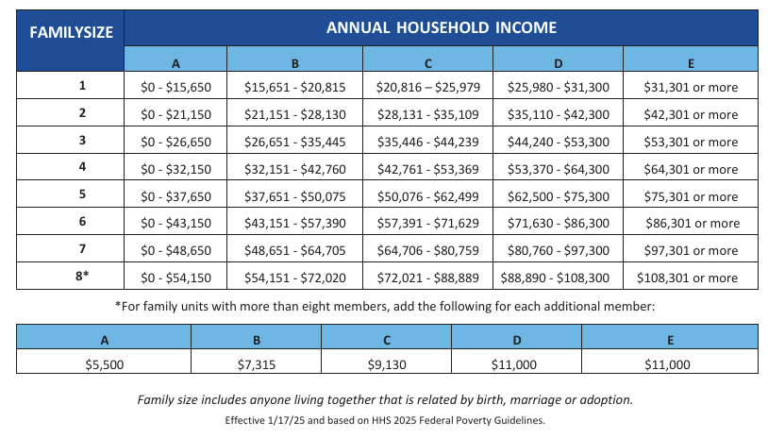
*Based on the 2025 Federal Poverty Guidelines for the 48 contiguous states and the District of Columbia. Please note that there are separate guidelines for Alaska and Hawaii, and that the thresholds would differ for sites in those two states. Sites in Puerto Rico and other outlying jurisdictions would use the above guidelines.

